# 

# 

# 

# 



Volunteer Handbook

# 

# 

# 

# 

# 

# 

# **TABLE OF CONTENTS**

## BoldYTH Volunteer Guide

* Becoming a Volunteer
* Joining the Team
* BoldYTH Leadership Standards
* Bethany Church Policies

## BoldYTH Leader Guide

* Leading Groups in BoldYTH
* Why Should You Make Disciples?
* Handling Difficult Situations
* Planning Center Instructions

# 

# 

# 

# 

# 

# 

BoldYTH Volunteer Guide

# 

# 

# BECOMING A BOLDYTH VOLUNTEER

## Welcome to the Family!

We’re so excited that you have decided to join us this semester as we serve the next generation here at Bethany Church! Our heart is to see youth enter into the life, family, and purpose of God for their lives.

Our goal is to see every junior high and high school student discovered, developed, and deployed through student discipleship. This ministry cares about the Great Commission and seeing revival happen in the lives of our youth. We are thankful for leaders, like YOU, partnering with us to shine the light of Jesus in the darkest of places.

The opportunity to serve in BoldYTH is an amazing chance to make an eternal impact on the next generation. We get to take part in the God moments that mark our young people, forever shaping the rest of their lives. As a BoldYTH Leader, you get the privilege to walk with students in their discovery of who God is and who He is to them. We believe that this generation is the hope for the world’s future. Whatever season of life you are in, there is a place for you in serving the next generation through BoldYTH!

We are glad you have given God your yes! We cannot wait to see what God is going to do in this new season!

***~ The BoldYTH Staff***

# JOINING THE TEAM

Before jumping in, we ask that anyone interested in serving with minors has been part of Bethany for at least 6 months. This helps us build a relationship and gives you time to get planted through services, Bgroups, Next Steps, and Purpose classes.

## How to Serve with Us

Step-by-Step Checklist for onboarding BoldYTH Leaders

* **Member of Bethany Church for 6 Months**

Build relationships and get rooted through serving, Bgroups, and Purpose classes.

* **Submit an Application on BoldYTH.la/leaders**

Share your background and heart for ministry.

* **Attend a Face-to-Face Interview**

Your campus Youth Director will contact you to set up a meeting.

* **Provide References**

We'll contact a couple of people who know your leadership experience.

* **Complete a Background Check**

Required for anyone serving with minors—quick and confidential.

* **Attend Training**

Learn safety protocols and get equipped to lead with confidence.

## Onboarding Resources

| **Our Church Resources** | **The Bible Project Videos:** |
| --- | --- |
| [**The Life Book**](https://bethany.life/life-01)  [**The Family Book 01 (Next Steps)**](https://bethany.life/family-01)  [**The Family Book 02 (Freedom)**](https://bethany.life/family-02)  [**The Purpose Book 01**](https://bethany.life/purpose-01)  [**The Purpose Book 02**](https://bethany.life/purpose-02) | The Bible Project is a nonprofit animation studio that produces short, creative videos designed to help people understand the themes, stories, and overall narrative of the Bible. Their videos make Scripture visually engaging, accessible, and thought-provoking, sparking meaningful conversations about God’s Word.  [Link for the Bible Project](https://bibleproject.com/#watch)  [Youtube Channel](https://www.youtube.com/user/jointhebibleproject) |

# BOLDYTH LEADERSHIP STANDARDS

As BoldYTH leaders, we set the standard for the next generation. Our lives speak louder than our words, and the way we live either draws students toward Christ or pushes them away. These disciplines and values define who we are, how we lead, and how we build a culture where students can encounter Jesus.

### SPIRITUAL SHARPNESS

Students follow leaders who *live* their faith. What we say matters less than how we live—our language, our posts, and what we consume reflect our walk with Christ. To lead well, we must prioritize prayer, fasting, and time in the Word, staying sensitive to God’s voice. Breakthroughs in students’ lives begin in our private devotion.

**Values Connected to Spiritual Sharpness:**

* **Excellence** – Eliminate distractions and pursue a culture that honors God.
* **Humble** – Lead with an “I get to” mindset, serving others with the gifts God has given.
* **Learner** – Continually grow in wisdom and leadership, following Jesus’ example.

### ACCOUNTABILITY

We are better together. Leaders must be honest about struggles—spiritual, emotional, financial, or otherwise—and seek support. Every leader should have accountability with a Pastor or Bgroup leader, and your Campus Youth Director should know who that is.

**Values Connected to Accountability:**

* **Order** – Lead your personal life well (family, finances, commitments). A life in order builds credibility.
* **Honor** – Respect the standards set before you and handle concerns by bringing them to the right people.

### DISCIPLESHIP

We are disciples who make disciples. We cannot pour into others if we are not being poured into ourselves. A disciple is more than a convert—they are actively growing to imitate Christ. Discipleship happens through teaching, modeling, and doing life together, combining invitation (relationship) with challenge (accountability and growth).

**Values Connected to Discipleship:**

* **Multiplier** – Raise up others to lead and invest in students so more lives can be reached.
* **Communicator** – Cast vision clearly and communicate expectations; unspoken expectations will never be met.

### COMMUNICATION & PUNCTUALITY

We honor God and our team by showing up on time, prepared, and staying until the job is done. If you’re late or unable to attend, notify your Campus Youth Director in advance. Clear and proactive communication builds unity—frustrations should always be brought to leadership directly, never through gossip. Healthy communication strengthens our team and protects our culture. Excessive miscommunication may result in a meeting with your Youth Director and/or removal from Bold Leadership.

**Values Connected to Communication & Punctuality:**

* **Initiative** – Take ownership, step up, and make things better without waiting to be asked.

**Countenance** – Lead with excellence in appearance, attitude, and approachability.

### **Scripture Standard**

*“20 In a wealthy home some utensils are made of gold and silver, and some are made of wood and clay. The expensive utensils are used for special occasions, and the cheap ones are for everyday use. 21 If you keep yourself pure, you will be a special utensil for honorable use. Your life will be clean, and you will be ready for the Master to use you for every good work.”*   
2 Timothy 2:20–21

**BETHANY CHURCH POLICIES**

### BETHANY LEADER HONOR CODE

As a leader in the Bethany Church family, you have a wonderful opportunity to embody and share the values of mature Christian living, reflecting the love and grace of Christ Jesus (see Ephesians 5:1–33). In your role as a Bethany leader, you are encouraged to consistently present yourself in a way that aligns with biblical principles, both in appearance and behavior. Your example is a powerful testament to your faith and a positive reflection of Christ.

Your commitment to Christ involves demonstrating the highest standards of personal conduct, which includes maintaining a disciplined life of Bible reading, prayer, and fasting. As a leader, you are invited to embrace a lifestyle that avoids activities such as:

| * Profanity * Gambling * Alcohol consumption * Tobacco use * Unethical practices * Illegal drugs | * Pornography * Sexual immorality * Any and all behavior that might cause the Holy Spirit to be grieved and others to stumble including misuse of social media |
| --- | --- |

By steering clear of these behaviors, you uphold the values that honor Christ and support the spiritual growth of others.

Your role as a leader is a profound expression of your heart’s commitment and is reflected in your actions. Viewing this honor code as a valuable aspect of your spiritual journey, you contribute positively to the growth of those around you and encourage them to follow in Christ’s footsteps as servant leaders. If you have any questions about the honor code or need guidance, a Bethany pastor is always available to support you.

### MISCONDUCT PREVENTION POLICY

* **Two-Adult Rule:** We avoid situations where a student is ever alone with just one adult.
* **Open Door Policy:** Doors stay open unless there’s a window for visibility.
* **Bathroom Guidelines:** Only women assist younger kids, and all bathroom trips are supervised with clear protocols.
* **Check-in/out Procedures:** Every child (7th grade and under) must be securely checked in and picked up with their unique security tag.
* **Sick Policy:** If your child is sick (fever, vomiting, contagious symptoms), we kindly ask you to keep them home so everyone stays healthy.
* **No Medication:** We don’t administer meds unless it’s a life-threatening situation. We ensure our Bold Staff Team is CPR certified; however, Youth Directors will actively pursue parental consent when dealing with minors and emergencies.
* **Accident Protocols:** Parents are notified immediately if injuries occur and reports are filed.
* **Mandated Reporting:** If abuse or neglect is ever suspected, our staff members are trained and required to report it to the proper authorities immediately. We take these steps seriously and follow all legal and church protocols to protect the children in our care.

# 

BoldYTH Leader Guide

# LEADING GROUPS IN BOLDYTH

## BOLD GROUPS

At BoldYTH, small groups (Bold Groups) are the heartbeat of discipleship. As a leader, your role is to model Christ, create healthy environments, and help students grow in their relationship with God. This guide will walk you from getting started to leading your own group with confidence.

## STEP 1. GETTING STARTED

**Connect** – Meet with your Campus Youth Director to talk about the group you’d like to lead this semester. They will set you up in the Planning Center so you can manage your group.

**Prepare** – Cover your group in prayer. Start inviting students personally—at church, in the lobby, during altar calls, through friends, at school, or at work. Follow up with reminders and take a step of faith to launch!

## STEP 2. FUNDAMENTALS OF A BOLD GROUP

**The Win** – Every student feels seen, known, and discipled toward Christ.

**What is a Disciple?**

* A disciple is any believer in Christ who follows in his teachings and demonstrates his character. However, it is helpful to differentiate between a “convert” and a “disciple.” A convert is one who simply believes in Jesus, and a disciple is someone who has devoted him- or herself to the progressive work of becoming more like Christ. **Every Christian is called to be a disciple of Christ.**

**What is Discipleship?**

* Discipleship is not a deeper Bible study; it’s Christ-centered multiplication. It’s building relationships and reproducing the life of Christ in others.
* Walking with students, teaching them to obey Jesus, and modeling a Spirit-led lifestyle.
* Not just coffee meetups or “deep talks”—it’s consistent, Christ-centered multiplication.

**Marks of a Disciple** – Devotional life, community in the local church, submission to spiritual authority, generosity, sanctification, Bible study, confession/repentance, serving, Spirit-filled living, and a missional lifestyle.

## STEP 3. BGROUP GUIDELINES

1. Show up **prepared**
2. Keep every group discussion **Christ-centered**
3. Take the main points **through the S.O.A.P. method**
   1. Scripture, Observation, Application, and Prayer
4. **Pray** together every meeting
5. **Honor the timeframe** your Youth Director has set
6. Track **attendance and members** in Planning Center

## STEP 4. YOUR FIRST SMALL GROUP

**Checklist Before You Lead**

* Confirm with your Campus Youth Director about what group you’re leading.
* Invite students personally.
* Make sure new students know when and where Bold Groups are at your campus.
* Be familiar with the Bold Groups topic and small group questions.
* Pray that God would use you in a unique way before you lead.

**Bold Groups Run Sheet**

Leader Huddle

* Arrive on time to meet with the team
* Pray together and set up for the night
* Ensure your assigned task is prepped and ready

Welcome Students

* Connect with students as they arrive
* Check in all students using an iPad / PCO Check-ins App
* Create a fun, life-giving atmosphere

Activities / Worship / Word

* Participate fully and engage with students
* Lead by example modeling authentic worship
* Listen attentively and take notes
* Capture key points for small group discussion

Bold Groups

* Work through the S.O.A.P. method
  + Scripture, Observation, Application, and Prayer
* Recommunicate the main idea / passage of Scripture
* Ask guiding questions and lead discussion

Leader Debrief

* Quick team debrief after all students have been picked up
* Celebrate wins and prepare for the next week
* Share any upcoming announcements with the team

## STEP 5. LEADING A GREAT DISCUSSION

* **Start light:** Use icebreakers or casual conversation to build connections.
* **Ask follow-ups:** Go deeper with meaningful, relevant questions.
* **Give space:** Silence is okay; let’s students think.
* **Refocus gently:** Guide back to the topic if conversation drifts.
* **End with encouragement:** Always finish with hope and strength.

**Dealing with Challenges**

* Come prepared with enough questions. All of our discussions need to revolve around Christ as the focus.
* Set expectations early. Explain the dynamic of the group and use your time to build relationships with the students.
* Handle distractions calmly, but firmly. Confidence is key.
* End every conversation on a positive note. Always have a moment of encouragement or strengthening.

## STEP 6. CREATING A HEALTHY CULTURE

* **Celebrate wins.** Birthdays, praise reports, milestones.
* **Stay connected outside of Bold Groups.** Sit together on Sundays, plan hangouts, serve together.
* **Make students feel known.** Learn their names, notice first-timers, call out giftings you see.
* **Encourage students to serve and lead** - even before they are “perfect”.

## STEP 7. SALVATION MOMENTS WITH STUDENTS

**Be ready** and sensitive to the Holy Spirit. If a student shows interest, lean in.

* **Keep it simple:**
  + God created us and loves us.
  + Sin separates us from God.
  + Jesus came, died, and rose again to restore our relationship with God.
  + Through faith and repentance, we receive forgiveness and new life.
* **Invite them to respond:** Ask them to pray and accept Jesus.
* **Lead them in prayer:**
  + Repent of sin. Confess your sin. Make Jesus Savior and Lord.

Romans 10:9 (ESV) says, “If you confess with your mouth that JESUS IS LORD and believe in your heart that God raised him from the dead, you will be saved.”

* **Celebrate big:** This is the greatest decision they’ll ever make!
* **Encourage next steps:** Water baptism at their campus. Follow up to get them signed up online.
* **Follow up:** Let your Youth Director know so the student can be discipled and supported in their new walk with Christ.

“*Therefore, go and make disciples of all the nations, baptizing them in the name of the Father and the Son and the Holy Spirit. Teach these new disciples to obey all the commands I have given you. And be sure of this: I am with you always, even to the end of the age." Matthew 28:19-20 NLT*

## STEP 8. WEEKENDS AT BETHANY

BoldYTH leaders are part of the whole church family.

* Attend weekend services on campus consistently.
* Arrive 15 minutes early and stay 15 minutes after your weekend service to connect with students.
* Consistent absence from weekend services can lead to removal from leadership.

## STEP 9. HANGING OUT WITH STUDENTS

* Partner with parents - always get approval!
* Never be alone with a student of the opposite sex.
* Always meet in groups with more than one adult.
* Keep environments safe and life-giving (music, movies, conversations).
* Daytime hangouts are preferred; evening activities should end by 9:00 PM.

# WHY SHOULD YOU MAKE DISCIPLES?

“And Jesus came and said to them, ‘All authority in heaven and on earth has been given to me. Go therefore and make disciples of all nations, baptizing them in the name of the Father and of the Son and of the Holy Spirit, teaching them to observe all that I have commanded you. And behold, I am with you always, to the end of the age’” (Matthew 28:19–20 ESV).

You should make disciples because all authority in heaven and on earth has been given to Jesus.

## Jesus’ authority speaks of two things:

1. **Our submission to Him**
   1. Jesus has authority over our lives. When we explicitly say, “He is Lord,” we implicitly say, “I am not.” We are submitted to Him. He doesn’t command us to go get jobs, get married, pursue an education, obtain success, earn money, start a family, or buy a house, but for many of us, that has become the pursuit. Culture commands us to pursue those things, but Christ commands us to make disciples. If you’re going to obtain those things but are not going to make disciples, you are not submitted to Jesus. He is not your Lord.
2. **Our commission from Him**
   1. We can’t just randomly pull another car over on the highway. It’s not because we’re not smart enough, strong enough, old enough, tall enough, experienced enough, etc. It’s because we haven’t been given the authority to do so by the law. That authority must be conferred onto a citizen by a higher authority. In a similar fashion, Jesus gives us authority in our lives. He is the higher authority that confers on us the authority to make disciples. You’ve been commissioned. You’re not stepping out in your own authority— you’re stepping out in His authority.

## PRACTICAL DISCIPLESHIP

**You’re a relational leader:** As you disciple students, build genuine, loving relationships with them. Empower them to follow Christ and God’s Word. Everything should be done in the spirit of love and honor. Do not lord over students, judge them harshly, parent them, or disqualify them.

**You’re an encouraging leader:** Lift up students emotionally, spiritually, and physically. Even if they have done something wrong or are in an unfortunate situation, stand with them and encourage them.

**You’re a Spirit-led leader:** God is your focus and His Word is your standard. Follow Him and His Word with passion and zeal. Don’t let your own preferences divert you from God’s Word. Also, listen to God’s voice as He speaks to you concerning your students.

# HANDLING DIFFICULT SITUATIONS

As a BoldYTH, you’ll walk with students through the highs and lows of life — including difficult and even traumatic moments. You are in a trusted role, but always remember:

**You are a leader first, not just a friend.**

You are also a **mandatory reporter** for **any illegal activity** involving students. Below is a breakdown of how to respond in both **non-legal** and **legal** situations.

## 

## Nonlegal Situations

We are not required by law to report these, but we do care deeply. Examples include: Gambling, Smoking/vaping, Drinking, Premarital sex, Suicidal thoughts, Harmful or risky behavior.

**What To Do:**

* **Inform your Youth Director** as soon as you're aware. Don’t wait.
* If the situation becomes serious, we’ll help the student communicate with their parents or guardians.

**Encouraging Student/Parent Communication:**

Within 24 hours of the student opening up:

* Encourage them to talk to their parents or guardians.
* They can do this:
  + **On their own** (we will follow up with parents afterward), or
  + **With a Bold leader present** for support.

The goal is **open, honest, and healthy communication** between students and families.

**Following Up**

* Some students come from strong, faith-filled homes. Others do not.
* Regardless of background, we walk with students through every season.
* Stay present — even when it’s tough.
* If a parent is uninvolved or unavailable, we still show the love, support, and trustworthiness of the church.

**Always** update your campus Youth Director about serious matters.

**Never** carry heavy information alone.

## 

## Legal Situations and Authorities

These MUST be reported immediately — no exceptions. Examples include:

* Abuse (physical, sexual, emotional)
* Abandonment or neglect
* Any serious threat to a student’s safety

**Your Responsibility:**

If you come across an issue like this, report it immediately to your youth director, and that director will help you report it to the proper authorities. Although your campus youth director will help, it is legally your responsibility to report abuse, neglect, or the immediate danger of a student. This should take place no longer than an hour after disclosure. If your campus youth director isn’t available, please contact your campus pastor immediately.

# PLANNING CENTER INSTRUCTIONS

### CREATING YOUR BOLD GROUP

*You will receive an email from Bethany Church and BoldYTH titled “You are now a Leader of (Group Name)*

### STEP 1. SETTING UP YOUR GROUP

The first time you log in to Groups, you may or may not need to set a password, depending on if you have previously set a password for one of our other apps.

On the [login page](https://groups.planningcenteronline.com/), select the *Need a password?* link below the email and password fields.

Enter the email address your administrator used to set up your profile, then a verification code will be sent to that email address. After entering the code, you will be able to create a password and then log in.

**YOUR GROUP IS NOW READY**

Once you create a password, you will be logged into your group. You can also access your group by opening the email *You are now a Leader of (Group Name)* and click *View Group.* You can also **Bookmark/Save** your **Planning Center Login Link** on your phone for easy access. <https://accounts.planningcenteronline.com/login/new>

However, the best thing to do is download the “Church Center” app to quickly view your groups all in one place.

### STEP 2. ADDING MEMBERS & ACCEPTING MEMBERSHIP REQUEST.

The first page you see when you select your group is a list of all your members. There are some quick actions you can take on this page, such as emailing members, removing them from your group, or printing a list of members.

You will also have the option to add new members from this page if your administrator has given you the permission to do so.

**Adding Members:** Type a person’s name into the Add a member field and select their name when it appears. If they don’t yet exist in the database, select Create a new member to add them to your database.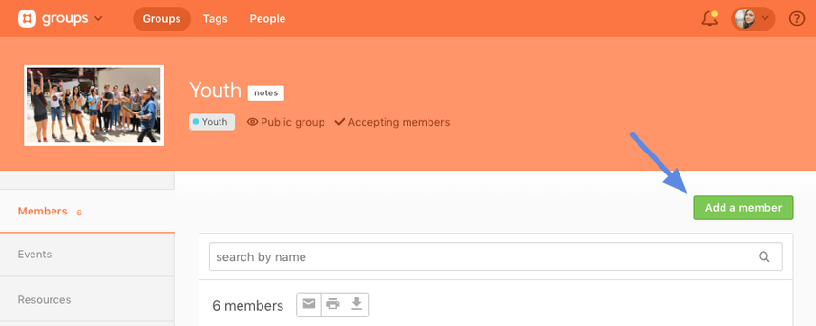

**Accepting or Rejecting Membership Request:** When someone requests to join your group, you will receive an email notification. You can either respond via the link in that email or respond from Groups. All requests will be displayed on top of your list of members.

### STEP 3. ADDING EVENTS & ATTENDANCE

**EVENTS & MEETINGS**

The Events tab shows you a calendar of upcoming events for your group, along with some quick actions you can take on each event. Once you select an event, you will see more details about that event, along with the option to edit the event.

**BoldYTH Staff** will already have added major events in your groups event page. From the event list, you can request RSVPs from your members for upcoming events and quickly view the responses.

**ATTENDANCE**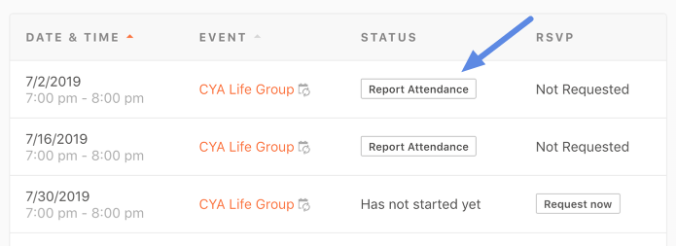

Attendance can be a key indicator of group health. **Attendance for BoldYTH B-Groups is one of the most important things you do as a B-Group Leader.** When group leaders take regular attendance at group events, BoldYTH Staff will know if the group has grown too large or become too small.

A group's Events tab shows the attendance status for each event. Events are listed in chronological order and show the date, name, and attendance if it's already been taken.

Click *Report Attendance* to be taken directly to the attendance roster.

You can also select the event and Click *Record Attendance* in the event page to access the attendance roster.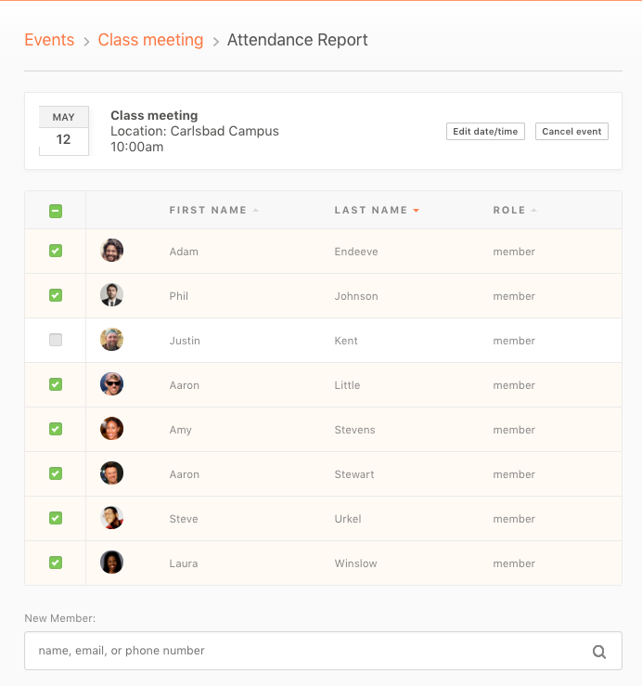

In the Attendance Report, put a check next to members who were present, and search for others who attended and want to be added as a member.To modify attendance for an event, go to the event page, and click *Modify* in the Attendance section.

Make any needed adjustments in the Attendance Report, and then click *Submit Attendance Report* to submit the change.

If your group didn't meet, click *Actually, We Didn't Meet* at the bottom of the screen, and then submit the report.

### STEP 4. SETTINGS

From the Settings tab, group leaders can modify group information such as name, description, and group image. **Because BoldYTH organizes its groups in a specific way, we ask leaders not to change the group name, picture, or group information without consulting BoldYTH Staff first.** However, leaders can update the contact information as needed.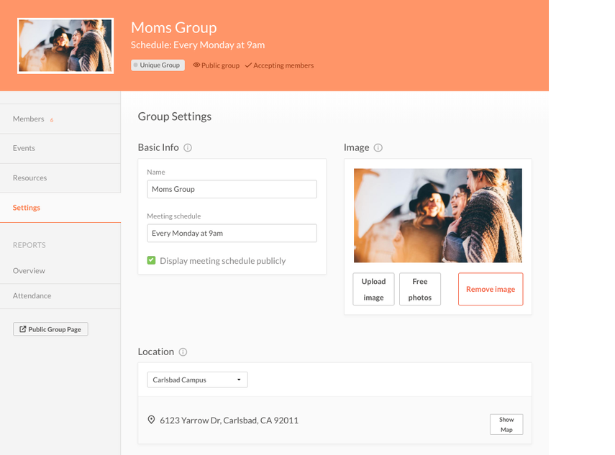

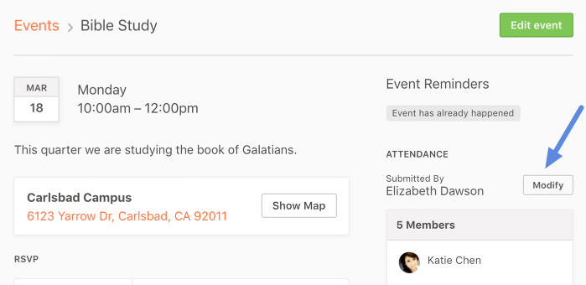

# BoldYTH | Commitment Form

We thank you for joining us this semester to serve our youth ministry. Please read through this Commitment Form and sign it at the end. We look forward to serving with you!

Your Name / Email *

| First & Last name | name@example.com |
| --- | --- |

Phone Number *

|  |
| --- |

Which Campus Do You Attend? *

|  |
| --- |

Which Ministry are you committing to serve with? * *Select all that apply.*

| * **Bold57**   5th - 7th Grade Bgroups   * **Bold Groups**   8th - 12th Grade Bgroups | * **Bold Nights & Bold Campus Nights**   5th - 12th Grade Services |
| --- | --- |

**I will lead myself by spending time in God’s words daily and being plugged into the life of Bethany Church on the weekend.**

*Our heart is that anyone who wants to pour into someone else must first be poured into. We ask all BoldYTH leaders to be in the life of Bethany on Sundays and in the Word to be filled up so they can pour out.*

**I will commit to serving in BoldYTH for the entire semester. My goal is to be there weekly for every Bold Group and/or Bold 57.**

*Because we are focusing on small groups, the responsibility of leaders and discipleship is greater. Discipleship needs consistency, so we need you to be consistent every week in discipling these students.*

*We also understand family emergencies, work emergencies/commitments, and vacations. We ask that there is over-communication, and if there is a date you know you will be gone to let your Youth Director and the co-leader know far in advance.*

**I will commit to be at all the monthly leader meetings.**

*We meet once a month with our leaders. These meetings are to grow together as a team, have small group training, cast vision, and take care of needs for the ministry. These are very important and are a high priority.*

**I will commit to connect with MY 1 / bgroup once a month.**

*It’s simple… just put in effort to connect with a student(s) outside of BoldYTH events and gatherings. It’s all about making disciples, and most of that happens outside of the church.*

**I have read through the BoldYTH Volunteer Handbook, all the expectations in this commitment form, and I am committed to the 4 expectations for BoldYTH, to making disciples, and to making an impact that will catalyze a global youth movement.**

Today’s Date *

|  |
| --- |